

**MINI-PROJECT REPORT V SEMESTER 2021**

**ON**

**Student Result Management System**

**University Rollno**-2014699

**Submitted by–** Kanika Kala

CSE Core 5th Semester

C-29

**GUIDED BY –** Ms. Meenakshi Maindola

**SUBMITTED TO–** Ms. Akansha Gupta

**INTRODUCTION**

This is a PHP and Mysql Project on **Online Student Result Management System** which is a web based PHP project and by using this system we can manage Student result online. With this system we not only manage student result, but also we can manage exam data. The main purpose of developing this project is to reduce the manual errors and convert result system into a computerized system.

An Online Student Result Management System in PHP is a very well organized and appropriate system to utilize. This Student Result Management System is not only for student users, but also it assists the management that proceeds with a large amount of pain to publish the student results in usual conditions.

This is project will help us to make the results easily accessible and student can get result wherever they want and by using whichever devices they can check their result because this is a fully responsive site made without the use Bootstrap libraries. From this site, student can print their result. One of the major advantages of this Student Result Management System is to makes the process extremely convenient for students. Under this system Student can search their result using valid email ids and their roll number.

The main rationale behind this PHP project is to supply examination result to the student in an easy way. This PHP project is helpful for students and institutions for publishing the results in an efficient way.

**Requirements of project:**

* **Hardware requirement:** Monitor, CPU, Mouse, Keyboard.
* **Software requirement:**
* **Operating system:** Windows
* **Code editor:** Visual Studio Code.
* **Languages used:** HTML, CSS, PHP, Java Script
* **Software required:** XAMPP

**Background and Motivation behind the project:**

* In recent years Universities and colleges have opted for providing platforms to students to look up their results from anywhere and anytime.
* The platform should seamlessly unravel and quicken the result management system with unique templates by providing the administration a secure database system for storing, evaluating and publishing the test scores and grades of candidates online. The database likewise allows the students to observe and look at the exam results on the web at whatever point necessary.
* Thus arises the need for developing a simple yet secure system that not only provides a fast access to the result, but also gives the management complete control over the data.
* One of the principal purposes of the system is to give the test results to the students in the as fundamental and exact way as possible. The administrator, teacher, professors, and staff can likewise modify and assess marks for the students whenever needed.

**Features of the project:**

1. Student can get result by Search Result by entering their email id and roll number.
2. Master user can see analytics data of total number of results published, total exam data, total student data, total subject data and total classes data.
3. Master user can Add Edit and Delete Classes data.
4. Master user can enable and disable the status of Classes under this System.
5. Master user can Add New Subject in particular classes and he or she can also edit or remove Subject data also.
6. Master user can Enable and disable status of Subject of particular class.
7. Master user can Add, Edit and Delete Student data.
8. Master user can Enable and Disable the status of student.
9. Master user can Add, Edit and Delete Exam data.
10. Master and sub-users user logins via faculty login using his/her user name and password.

**Structure of Data in the database:**

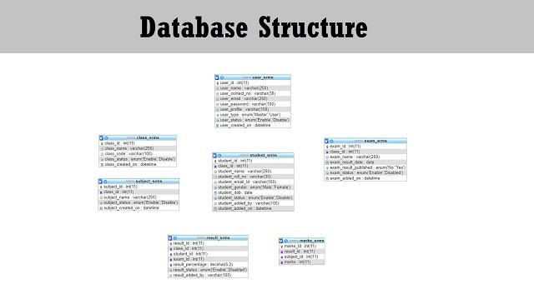

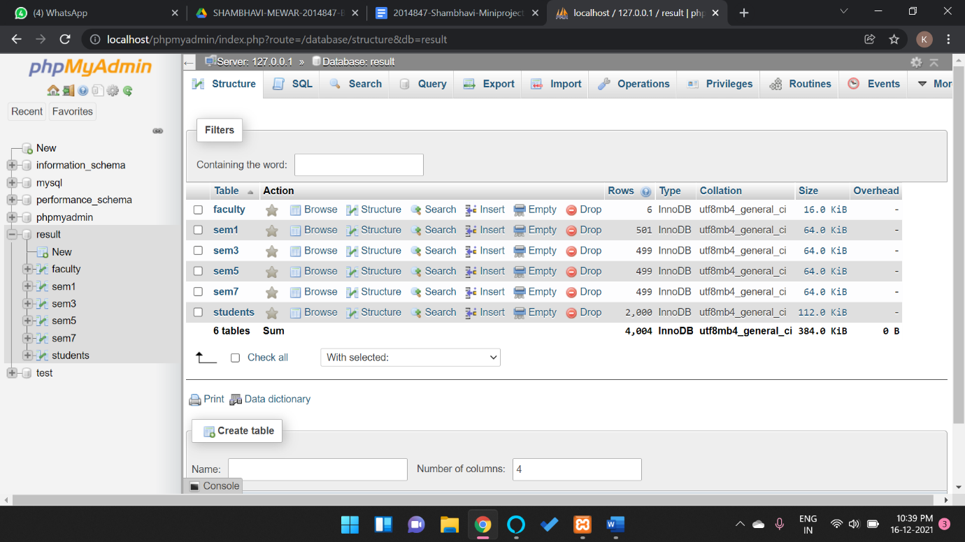

**Methodology followed:**

The landing page of the website is the student login with following features

* Student can login using assigned login id and password
* The credentials will be mapped with the database, if matched then the student will be shown his/her result, otherwise an error message will be displayed saying invalid id or password.
* After viewing the result the student can logout.

The second portal is faculty login which performs the following operations

* Faculty can login using assigned login id and password.
* The credentials will be mapped with the database, if matched then the faculty will be able to perform operations, otherwise an error message will be displayed saying invalid id or password.
* The faculty can add/delete/modify student entry
* After performing operations, the logout page will lead to the login page.

**Result Analysis:**

* Once we’ve have set up the database and moved on from the coding part, now we want to run this Online Student Result Management System in our local computer.
* This is what the student login would look like:

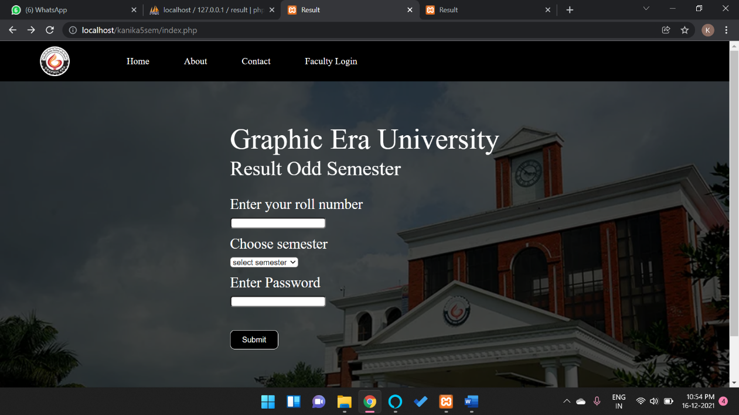

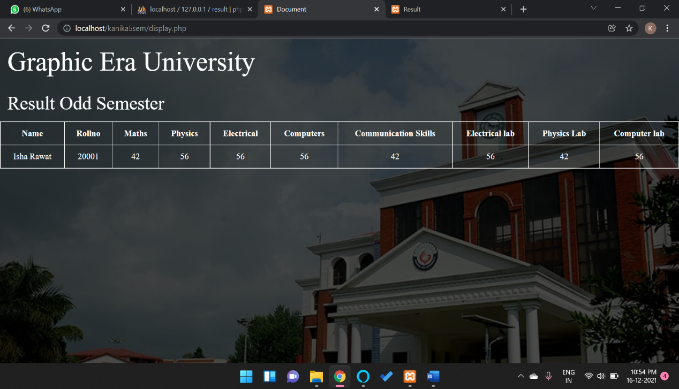

* By clicking on the ‘Faculty Login’ link in the navigation bar, the user will be redirected to the faculty login page that would look something like this:

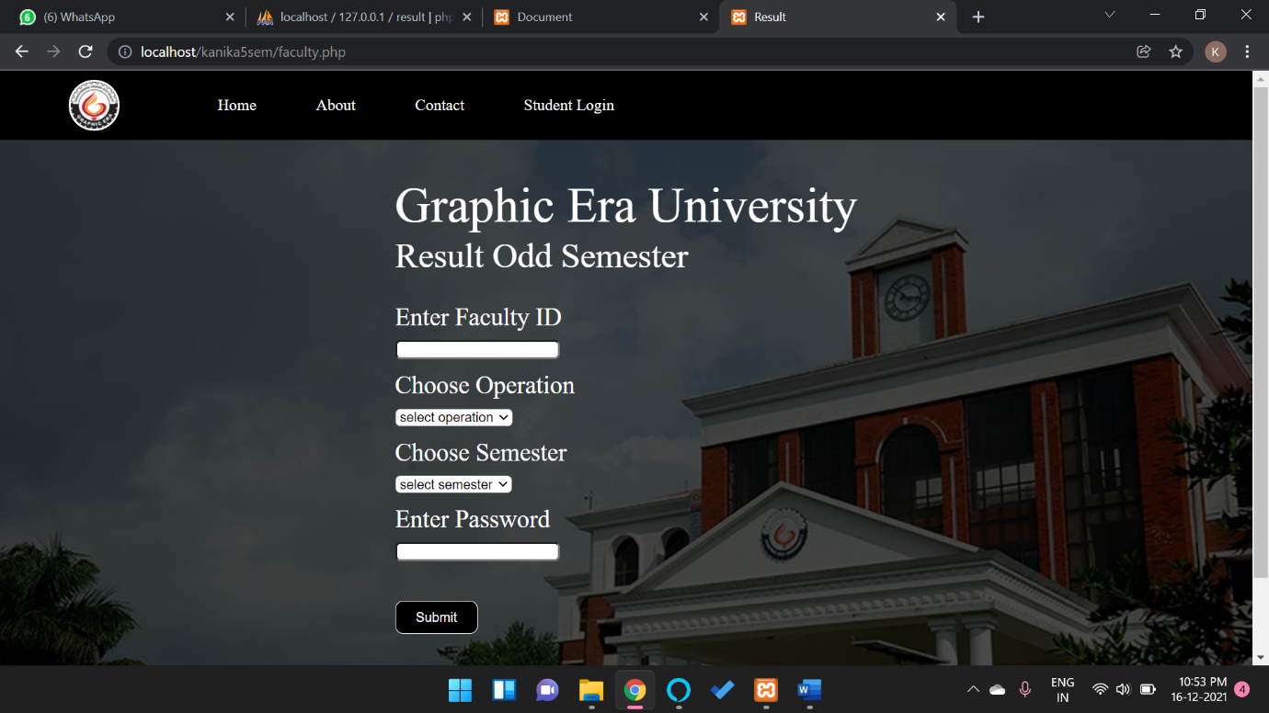

* Redirected page from faculty login where the Master and sub_users can bring about changes in the database:

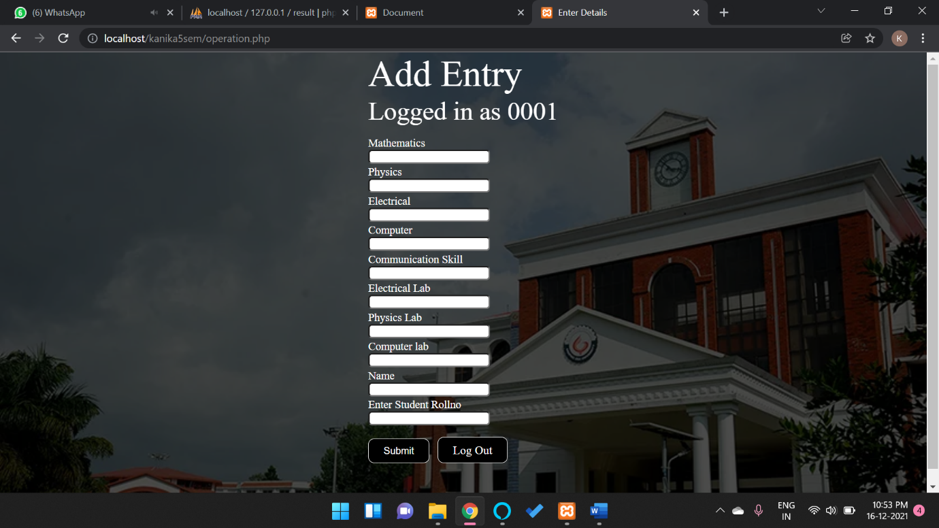

**Bibliography:**

[www.youtube/codewithharry.com](http://www.youtube/codewithharry.com)

[www.w3schools.com](http://www.w3schools.com)

VS Code-MDN reference

**Thank You**